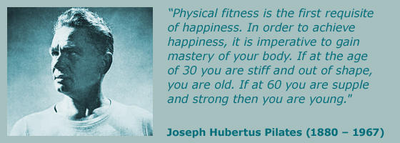

What is Stott Pilates?
Stott Pilates is based on the original works of German-born Joseph Pilates who designed a series of exercises that uses both mental and physical techniques to condition the body. His methods were used primarily by dancers, however, in recent years these methods have been introduced into the health and fitness industry. .
Stott Pilates training programmes are ideal for personal trainers, physiotherapists, health professionals, experienced group exercise teachers and Pilates enthusiasts.
Many things have changed since Joseph Pilates first developed his techniques. We believe that our training programmes bring his techniques into the 21st Century by combining his principles with all the latest research and knowledge we have about fitness, exercise and core stability.
This has enabled us to create the Stott Pilates Method which is a scientific and educationally sound programme for fitness and health professionals, which has been developed by working extensively with physiotherapists, physiologists and qualified Pilates educationalists.

The Benefits
• Improves posture
• Builds core strength and stability
• Improves spinal mobility and flexibility
• Increases flexibility, balance and co-ordination
• Prevents injury and heightens body awareness
• Enhances athletic performance
• Relieves stress and back pain
About Anita
Anita has been working in the field of health and fitness for over 40 years. After graduating from the Kenneth Cooper Institute of Aerobic Research in Dallas Texas as an Exercise specialist in 1985, Anita took her passion for helping people experience the benefits of regular exercise to the Middle East. In Muscat, she developed her own fitness business based on Group Exercise and Personal Training, worked as Fitness Manager for The Middle East’s first ladies only 5 star Health Club and Spa, before moving on to manage Sport & Leisure Facilities in Dubai. Anita first trained in Pilates at the Pilates Institute in London in 2002 under the renowned Michael King but has since retrained with Stott Pilates recognizing that their contemporary method offers a more in-depth approach with a greater variety of movement and challenge. Anita relocated back to the UK in summer of 2010 and has since been teaching Pilates full-time both in group sessions and on a one-to-one basis in Clubs and Studios around the SW Greater Manchester area.

Qualifications/Training (summary)
MSc Exercise & Nutrition
REPS Level 3 Fitness Instructor and Personal Trainer
Pilates Institute Certificate in Pilates
Stott Pilates – Matwork and Reformer
ACE (American Council on Exercize) Group Exercise Instructor, Personal Trainer and Lifestyle/Weight Management Consultant
Institute of Aerobic Research Exercise Specialist
Co-Active Life Coach
Attendance of over 20 Fitness Conventions in the USA, UK and Middle East

